IKEA Glow Dining Set

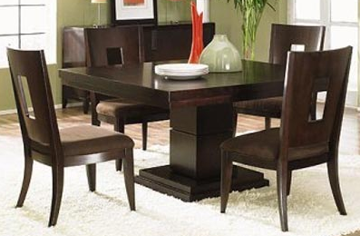

|  |
| --- |
| **DESCRIPTION** |
| IKEA introduces stylish wooden dining set with a polished glowing wooden finish on top the set of tables and chairs is perfect to create the perfect the lighting surrounding. The rich scratch proof wood helps the table to maintain its glow for longer period of time. The durable strength of table is so concave that if the things are kept on the edge the table will still manage to hold weight. |

|  |  |  |
| --- | --- | --- |
| **Price** | **1360$** | |
| **Dimensions** | **Table H** x **W** x **L** | **45in x 35in x 45in** |
| **Chairs H** x **W** x **L** | **30in x 24in x 28in** |
| **Features** | **Four Chairs and One Table with supporting thick handle enables table to hold weight. Slim chairs allow the user to maintain balance as well as adapt to pressure.** | |
| **Finished** | **Mirror Blanchester Wood** | |
| **Available in** | **Green and Brown** | |